CLC一維非均相模式

(1)

固體顆粒內氣體質量平衡修改

$\frac{∂(ε_{c}C_{c,i})}{∂t}=-a_{v}\left(k_{c,i}(C_{c,i}-C_{i})\right)+ρ_{s}\sum{R_{i}}$ (1)

固體顆粒與內部氣體能量平衡

$\left({(1-ε}_{c}\right)ρ_{s}C_{p,s}+ε_{c}C_{p,c}C_{T,c})\frac{∂T_{c}}{∂t}={-h}_{f}a_{v}\left(T_{c}-T\right)+ρ_{s}\sum{{\left(-∆H_{i}\right)(R}_{i})}$ (2)

流體各成分i質量平衡

$\frac{∂(ε_{b}C_{i})}{∂t}=-\frac{∂(uC_{i})}{∂z}+k_{c,i}a_{v}(C_{c,i}-C_{i})$ (3)

流體能量平衡

$\frac{∂(ε_{b}C_{p,f}C_{T}T)}{∂t}=-\frac{∂(uTC_{p,f}C_{T})}{∂z}+h_{f}a_{v}(T_{c}-T)$ (4)

動量平衡

$\frac{dP}{dz}=-\left(\frac{1-ε_{b}}{{ε_{b}}^{3}}\right)\left(\frac{ρu_{0}^{2}}{d_{p}}\right)\left(\frac{150}{{Re}_{p}}+1.75\right)$ (5)

$${Re}_{p}=\frac{ρu_{0}dp}{(1-ε_{b})μ}$$

initial condition(forward flow pass at t = 0)



boundary condition (forward flow pass at z = 0)

$\frac{∂C_{i}}{∂z}∣_{z=L}=\frac{∂T}{∂z}∣_{z=L}=0$ (6)

$P∣_{z=L}=P_{out}$ (7)

boundary condition (backward flow pass at z = L)

$\frac{∂C_{i}}{∂z}∣_{z=0}=\frac{∂T}{∂z}∣_{z=0}=0$ (8)

$P∣_{z=0}=P_{out}$ (9)

固體質量平衡

$\frac{∂C_{NiO}}{∂t}=\acute{C_{NiO}}\left(-\frac{∂X}{∂t}\right)=\left(2r_{1}+r_{2}+r_{3}+r_{4}\right)*Mw_Ni$ (10)

$\frac{∂C_{Ni}}{∂t}=\acute{C_{NiO}}\frac{∂X}{∂t}=\left(2r_{1}+r_{2}+r_{3}+r_{4}\right)*Mw_Ni$ (11)

$\frac{∂X}{∂t}=\frac{2r_{1}+r_{2}+r_{3}+r_{4}}{\acute{C_{NiO}}}*Mw_Ni$ (12)

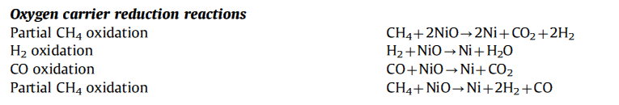

氧載體初始濃度也是以Heterogeneous modeling of chemical-looping combustion. Part 1: Reactor model 所提供資訊

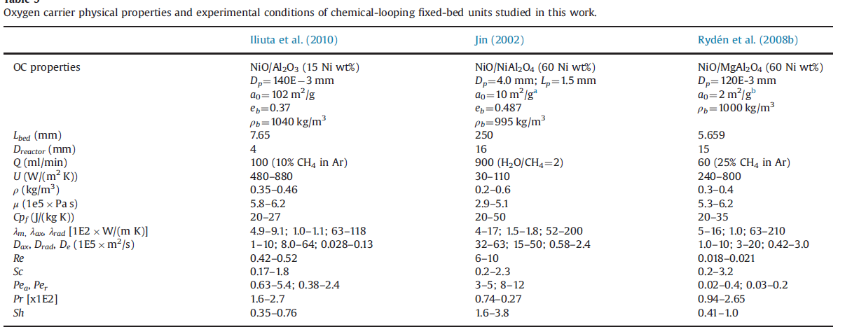

以重量百分濃度做為依據 $\acute{C_{NiO}}=0.6$

攜氧載體的物體性質: Heterogeneous modeling of chemical-looping combustion. Part 1- reactor model-2013

還原反應式

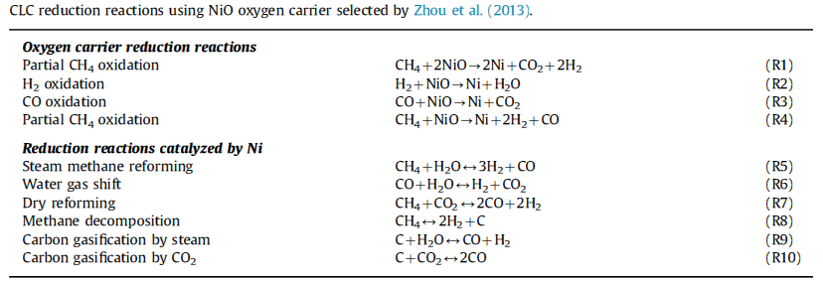

反應動力學

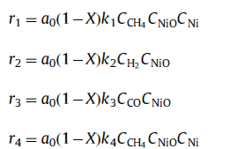

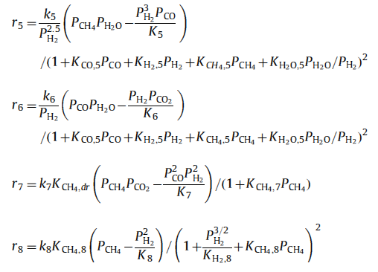

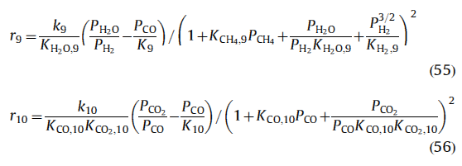

氣體與固體總質量平衡

$A∆z\left(1-ε_{b}\right)ρ_{OC}\frac{∂C_{NiO}}{∂t}=F_{w,z}-F_{w,z+∆z}$ (13)

$\frac{∂F_{w}}{∂V}=-\left(1-ε_{b}\right)ρ_{OC}\frac{dC_{NiO}}{dt}$ (14)

$\frac{∂F_{w}}{∂V}=\frac{∂(C_{total}{Mw}_{total}uA)}{A∂z}=\frac{∂(C_{total}{Mw}_{total}u)}{∂z}$ (15)

$$\frac{∂\left({Mw}_{total}C_{total}u\right)}{∂z}=\frac{{\left({Mw}_{total}C_{total}u\right)}_{z+∆z}-{\left({{Mw}_{total}C}_{total}u\right)}_{z}}{∆z}$$

$= \left(1-ε_{b}\right)ρ_{OC}\acute{C_{NiO}}\frac{∂X}{∂t}\frac{{\frac{1}{2}Mw}_{O_{2}}}{{Mw}_{Ni}}$ (15-1)

$= (1-ε_{b})ρ_{OC}\left(2r_{1}+r_{2}+r_{3}+r_{4}\right)*Mw_Ni\frac{{\frac{1}{2}Mw}_{O_{2}}}{{Mw}_{Ni}}$ (15-1)

$= (1-ε_{b})ρ_{OC}\left(2r_{1}+r_{2}+r_{3}+r_{4}\right)*{\frac{1}{2}Mw}_{O_{2}}$ (15-1)

$${\left({Mw}_{total}C_{total}u\right)}_{z+∆z}-{\left({{Mw}_{total}C}_{total}u\right)}_{z}$$

$=\left(\left(1-ε_{b}\right)ρ_{OC}\acute{C_{NiO}}\frac{∂X}{∂t}\frac{{\frac{1}{2}Mw}_{O_{2}}}{{Mw}_{Ni}}\right)∆z$ (15-2)

$=((1-ε_{b})ρ_{OC}\left(2r_{1}+r_{2}+r_{3}+r_{4}\right)*{\frac{1}{2}Mw}_{O_{2}})∆z$ (15-2)

${\left(u\right)}_{z+∆z}=\frac{\left\{( (1-ε_{b})ρ_{OC}\left(2r_{1}+r_{2}+r_{3}+r_{4}\right)*{\frac{1}{2}Mw}_{O_{2}})∆z+{\left({{Mw}_{total}C}_{total}u\right)}_{z}\right\}}{{\left({Mw}_{total}C_{total}\right)}_{z+∆z}}$ (15-3)

$F_{w}$*、 ${Mw}_{total}$ 與 $C_{total}$ 分別為氣體質量流率、氣體混合物之分子量與氣體混合物之總濃度。*

單位

$\frac{m}{s}=\left(\left(\frac{kgOC}{m^{3}}\frac{kgNi}{kgOC}\frac{1}{s}\right)m+\frac{kg}{mol}\frac{mol}{m^{3}}\frac{m}{s}\right)*\frac{mol}{kg}\frac{m^{3}}{mol}$

u_s(i) = (((1-porosity_bed)*ro_solid*CM_NiO_in*X*0.5*Mw_O2/Mw_Ni)*dz+(Mw_t(1)*u_s(1)*CM_t(1)))/Mw_t(i)/CM_t(i); %Gas superficial velocity (m/s)

模式假設

1. 體積恆定的球形氧載體
2. 忽略流動方向擴散效應
3. 忽略觸媒內部效應只考慮觸媒表面

4. 假設絕熱反應器

5. 假設徑向之濃度與溫度為均一分佈

**Concentrations:**

基本關係：

[=] mol/m3 )

初始氧載體濃度:

$$\acute{C_{NiO}}=0.6$$

**Flow rates:**

進料條件:

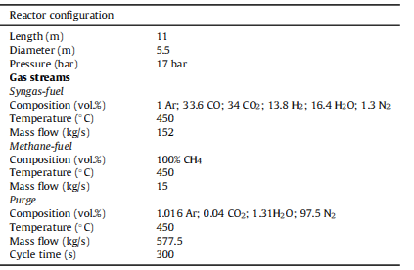

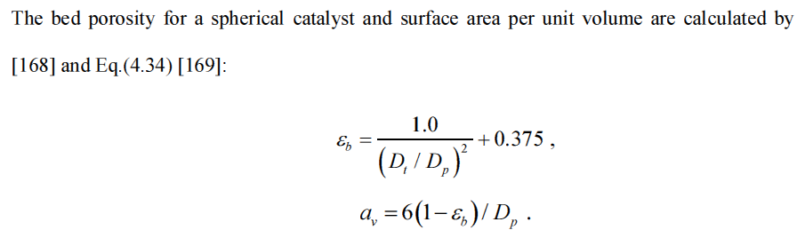

**Porosity of fixed bed :**

$ε_{b}=\frac{1}{{(D_{t}+D_{p})}^{2}}+0.375$ (16)

$D_{t}:$ Diameter of tube (m)

$D_{p}:$ Diameter of particle (m)

Particle surface area:

$a_{v}=6(1-ε_{b})/D_{p}$ [=] 1/m (17)

Partical Reynold number：

${Re}_{p}=\frac{ρu_{0}D_{p}}{μ}$ (18)

Schmidt number:

$Sc=\frac{μ}{ρD_{m,i}}\frac{1}{{Mw}_{i}}$ (19)

Heat capacity of fluid

${Cp}_{i}=A+B\left(\frac{C}{Tsinh{\left(\frac{C}{T}\right)}^{2}}\right)+D(\frac{E}{Tsinh{\left(\frac{E}{T}\right)}^{2}})$ [=] J/(mol*K) (20)

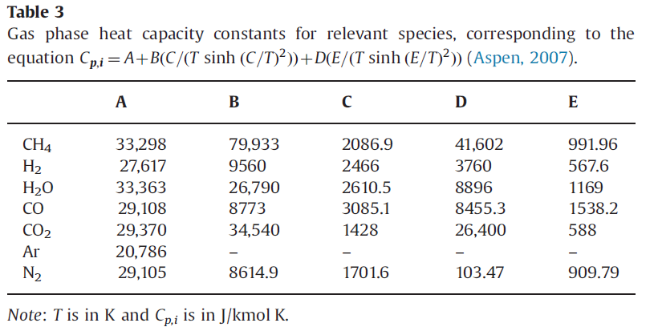

流體莫耳熱容量: Heterogeneous modeling of chemical-looping combustion. Part 1- reactor model-2013

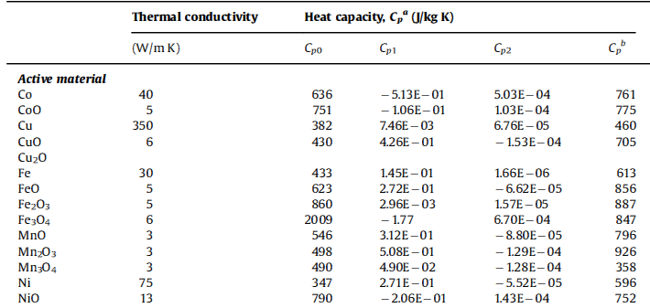

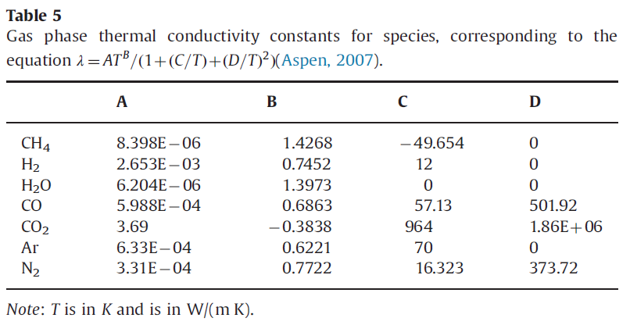

氣相的熱傳導: Heterogeneous modeling of chemical-looping combustion. Part 1- reactor model-2013

Gas phase viscosity constant

$m_{i}= AT^{B}/(1+\left(\frac{C}{T}\right)+{(\frac{D}{T})}^{2})$ [=] N*s/ m2 (23)

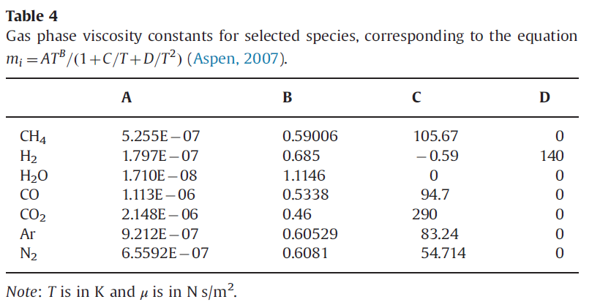

氣體黏度: Heterogeneous modeling of chemical-looping combustion. Part 1- reactor model-2013

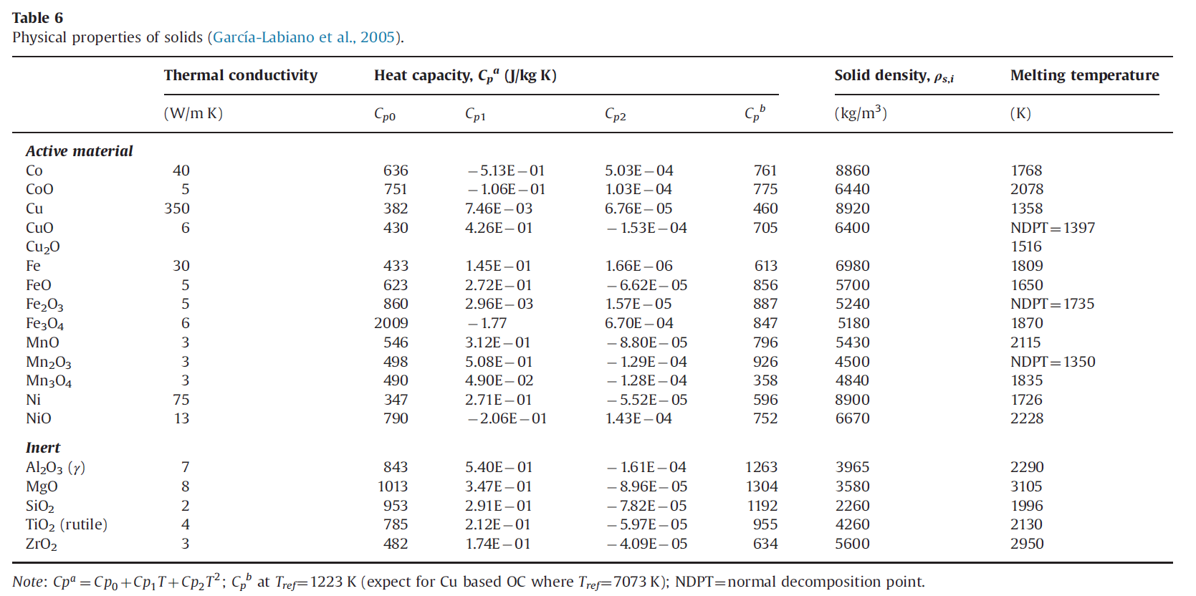

**Heat capacity of solid phase**

${Cp}_{t}={Cp}_{0}+{Cp}_{1}T+{Cp}_{2}T^{2}$ [=] J/Kg*K (21)

固體的物理性質: Heterogeneous modeling of chemical-looping combustion. Part 1- reactor model-2013

Boundary conditions:

$$F_{j}=F_{j,in}, {T=T}_{in}, { P=P}_{in} at z=0$$

質傳與熱傳系數

$k_{c,i}=0.357R_{e}^{-0359}S_{c}^{-2/3}\frac{G}{ρε_{b}}$ (24)

$h_{f}=1.37\left(\frac{0.357}{ε_{b}}\right)(\frac{C_{p,f}}{{Mw}_{total}}G)R_{e}^{-0359}S_{c}^{-\frac{2}{3}}$ (25)

因次分析

$k_{c,i}\left[=\right]\frac{m}{s}=\frac{kg}{m^{2}s}\frac{m^{3}}{kg}$

$h_{f} \left[=\right]\frac{W}{m^{2}K}\left[=\right]\frac{J}{{s∙m}^{2}K}=\frac{J}{molK}\frac{kg}{m^{2}s}\frac{mol}{kg}$

熱傳系數的部分需再多除以總分子量才符合單位